**Dynamic Memory Allocation in C using malloc(), calloc(), free() and realloc()**

* Difficulty Level : [Easy](https://www.geeksforgeeks.org/easy/)
* Last Updated : 09 Dec, 2021

Since C is a structured language, it has some fixed rules for programming. One of them includes changing the size of an array. An array is a collection of items stored at contiguous memory locations.

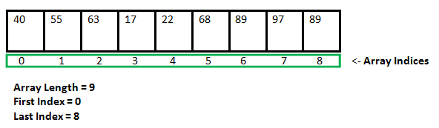

As it can be seen that the length (size) of the array above made is 9. But what if there is a requirement to change this length (size). For Example,

* If there is a situation where only 5 elements are needed to be entered in this array. In this case, the remaining 4 indices are just wasting memory in this array. So there is a requirement to lessen the length (size) of the array from 9 to 5.
* Take another situation. In this, there is an array of 9 elements with all 9 indices filled. But there is a need to enter 3 more elements in this array. In this case, 3 indices more are required. So the length (size) of the array needs to be changed from 9 to 12.

This procedure is referred to as **Dynamic Memory Allocation in C**.  
Therefore, C **Dynamic Memory Allocation** can be defined as a procedure in which the size of a data structure (like Array) is changed during the runtime.  
C provides some functions to achieve these tasks. There are 4 library functions provided by C defined under **<stdlib.h>** header file to facilitate dynamic memory allocation in C programming. They are:

1. malloc()
2. calloc()
3. free()
4. realloc()

Let’s look at each of them in greater detail.

**C malloc() method**

The **“malloc”** or **“memory allocation”** method in C is used to dynamically allocate a single large block of memory with the specified size. It returns a pointer of type void which can be cast into a pointer of any form. It doesn’t Initialize memory at execution time so that it has initialized each block with the default garbage value initially.

**Syntax:**

ptr = (cast-type*) malloc(byte-size)

**For Example:**

***ptr = (int*) malloc(100 * sizeof(int));*** *Since the size of int is 4 bytes, this statement will allocate 400 bytes of memory. And, the pointer ptr holds the address of the first byte in the allocated memory.*

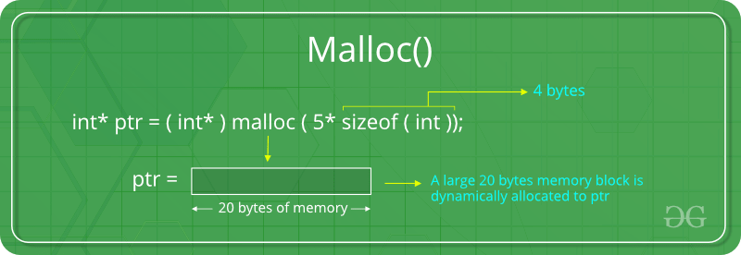

If space is insufficient, allocation fails and returns a NULL pointe

**C calloc() method**

1. **“calloc”** or **“contiguous allocation”** method in C is used to dynamically allocate the specified number of blocks of memory of the specified type. it is very much similar to malloc() but has two different points and these are:
2. It initializes each block with a default value ‘0’.
3. It has two parameters or arguments as compare to malloc().

**Syntax:**

ptr = (cast-type*)calloc(n, element-size);

here, n is the no. of elements and element-size is the size of each element.

**For Example:**

***ptr = (float*) calloc(25, sizeof(float));*** *This statement allocates contiguous space in memory for 25 elements each with the size of the float.*

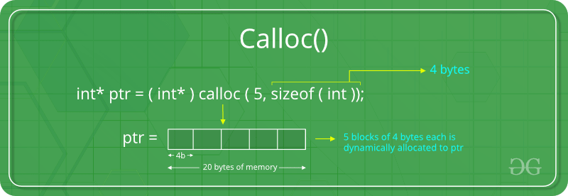

If space is insufficient, allocation fails and returns a NULL pointer.

### C free() method

**“free”** method in C is used to dynamically **de-allocate** the memory. The memory allocated using functions malloc() and calloc() is not de-allocated on their own. Hence the free() method is used, whenever the dynamic memory allocation takes place. It helps to reduce wastage of memory by freeing it.

**Syntax:**

free(ptr);

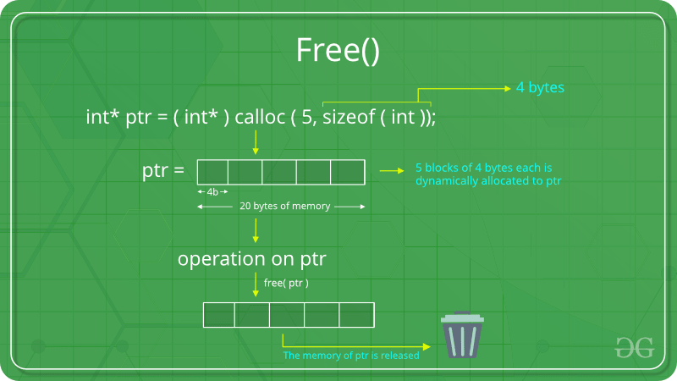

### C realloc() method

**“realloc”** or **“re-allocation”** method in C is used to dynamically change the memory allocation of a previously allocated memory. In other words, if the memory previously allocated with the help of malloc or calloc is insufficient, realloc can be used to **dynamically re-allocate memory**. re-allocation of memory maintains the already present value and new blocks will be initialized with the default garbage value.

**Syntax:**

ptr = realloc(ptr, newSize);

where ptr is reallocated with new size 'newSize'.

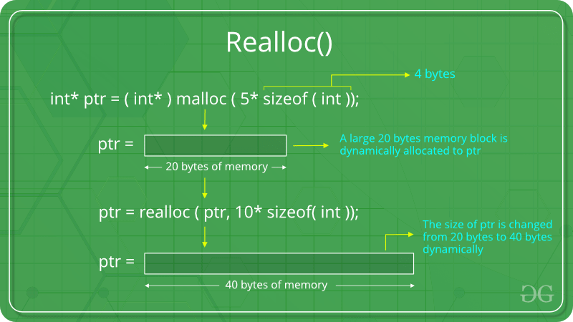

If space is insufficient, allocation fails and returns a NULL pointer.